# Group: Satenik, Arvin, Gisane

# Report

# “Saving Peppa”

First of all lets plot the histogram of healthy mice and see the frequent weight. So plotting the weight and treatment of the healthy mice(naive) gave the average weight which is 20.18g. Using these codes.

*z <- dt1$Weight[dt1$Treatment =="Naive"]*

*hist(z, main = "Healthy mice", xlab = "Weight")*

*mean(z)*

The histogram we got is,

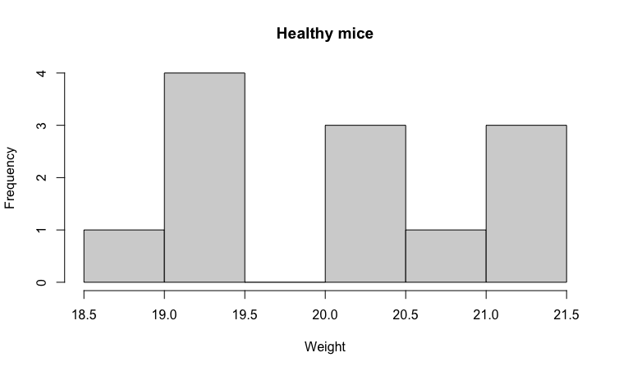

Where we understood that the most frequent weight is between 19.0 to 19.5.

Next we plotted the negative control and as expected their average weight decreased and the mean was 14.73g. Using these codes.

*t <- dt1$Weight[dt1$Treatment =="Negative Control"]*

*hist(t, main = "Treated with LPS", xlab = "Weight")*

*mean(t)*

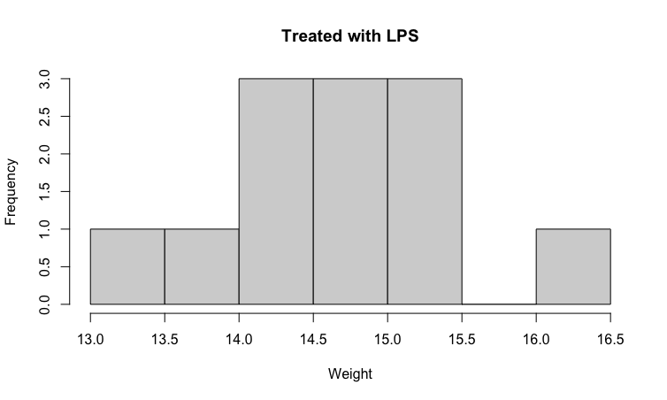

Then, taking into the consideration on of the provided codes,

*p1 <- ggplot(dt1,*

*aes(x = Treatment,*

*y = Weight,*

*group = ID,*

*fill = Diet)) +*

*geom_point(shape = 21,*

*size = 3,*

*position = position_dodge(0.3)) +*

*scale_y_continuous("Weight (gm)") +*

*theme_bw() +*

*theme(axis.text.x = element_text(angle = 45,*

*hjust = 1))*

*tiff(filename = "data/dotplot.tiff",*

*height = 5,*

*width = 6,*

*units = 'in',*

*res = 300,*

*compression = "lzw+p")*

*print(p1)*

*graphics.off()*

*print(p1)*

We got this dot plot.

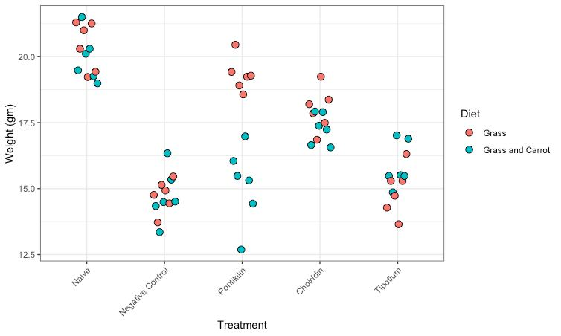

Analysing the graph we can understand that each drug had its own effect on mice, but for example we can see that Pontikilin had a positive effect on grass eating mice. Since our patient prefers carrot rich food, we can conclude that Pontikilin was not a good idea, because it had no effect on grass and carrot eating mice’s weight. Tipotium is also not a better option, because there is almost no difference between the Negative control group.

Now if we take the closer look to Choiridin effect, we can conclude that the best drug would be this one, since their weight increased and gets closer to the mean of healthy mice which was 20.18g and the mice who were treated with this drug got average weight of 17.63g.

*x <- dt1$Weight[dt1$Treatment =="Choirídin"]*

*hist(x, main = "Choiridin effectiveness", xlab = "Weight")*

*mean(x)*

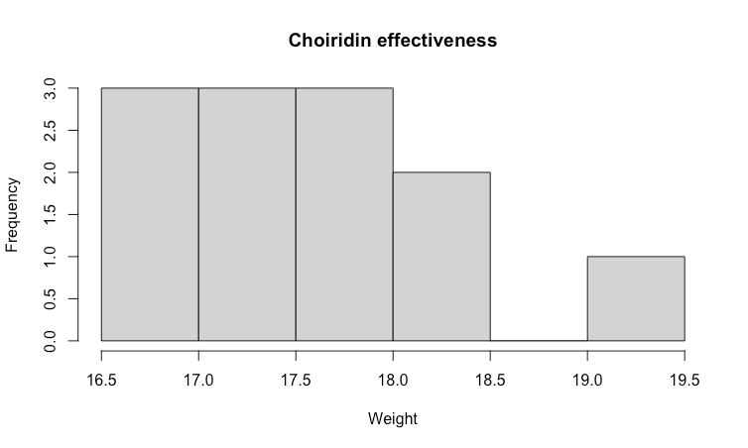

Now lets take into consideration the t-test to make better considerations. Using this code.

*t.test(z, t)*

We have conducted the t-test between healthy mice and the mice that were treated with LPS(negative control), which resulted to this,

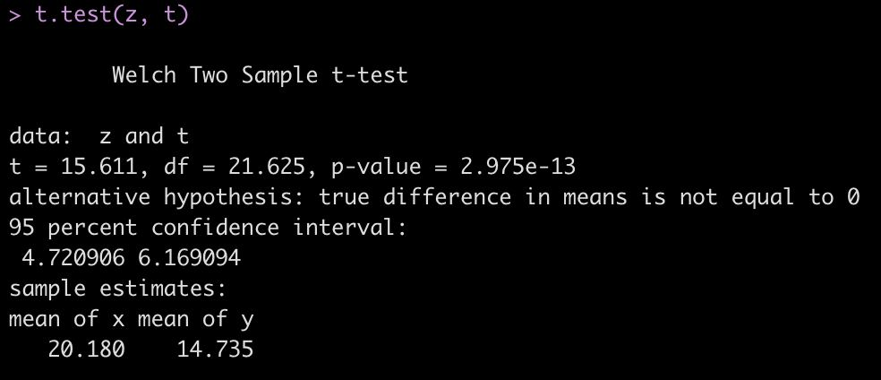

Where we can see that p-value is less than 5, which implies that our test is statistically significant.

Now lets test the healthy mice and mice who were treated with Choiridin.

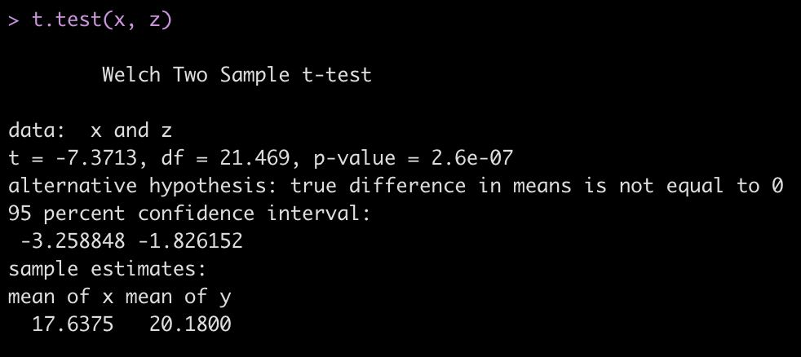

Same assumptions here.

Limitations:

* We didn’t have the Positive control group, who could the mice that already had the treatments before.